**MongoDB Administrative Tasks**

**MongoDB Environment Details**

**Mobile App**

|  |  |
| --- | --- |
| **Server** | **IP Address** |
| pngmobiledb01v.ng.sbicdirectory.com | 10.234.18.142 |
| pngmobiledb02v.ng.sbicdirectory.com | 10.234.18.143 |
| pngarbiter.ng.sbicdirectory.com | 10.234.18.141 |
| yngmobiledb01v.ng.sbicdirectory.com | 10.234.179.212 |
| yngmobiledb02v.ng.sbicdirectory.com | 10.234.179.213 |

**OS user: root**

**To login to Mongo Shell**

**Type at the prompt:**

mongo -u sysdba -p

Password: sysdba

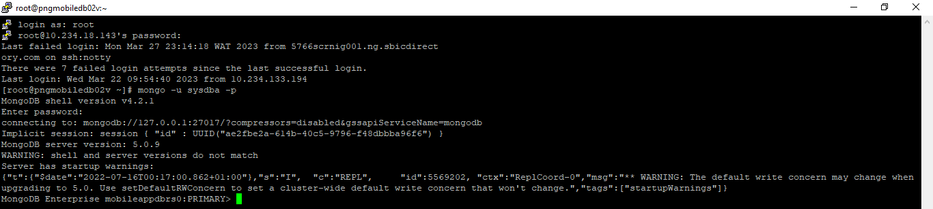

**Create a user on the database**

use admin

db.createUser(

{

user: "A226547",

pwd: "STanbic_1234#",

roles: [

{ role: "read", db: "stanbic" } ]

}

)

**Drop a user**

use admin

db.dropUser("A177909")

**Create Role, Grant Role, Grant Privileges**

use stanbic

db.createRole(

{

role: "CreateViewSupport",

privileges: [

{ resource: { db: "stanbic", collection: ""}, actions: [ "createCollection" ] }

],

roles: []

}

)

use stanbic

db.grantRolesToUser(

"support",

[

{ role: "CreateViewSupport", db: "stanbic" }

]

)

use stanbic

db.grantPrivilegesToRole(

"CreateViewSupport",

[

{ resource: { db: "stanbic", collection: "UniqueTransactedUsersandDeviceID" }, actions: [ "update", ] }

]

)

use stanbic

db.grantPrivilegesToRole(

"CreateViewSupport",

[

{ resource: { db: "stanbic", collection: "UniqueTransactedUsersandDeviceID" }, actions: [ "collMod","find" ] }

]

)

db.createRole(

{

role: "foobarRole",

privileges: [

{ resource: { db: "exampleDb", collection: "bar" }, actions: [ "createCollection", "createIndex", "find", "insert", "update" ] }

],

roles: []

}

)

**MongoDB log rotate:** To delete log file first run the command below which backs up the file and creates a new log file

db.adminCommand( { logRotate : 1 } )

**To Start/Stop/Status of MongoDB on Mobile App DB**

**Start**

systemctl start mongod

**Stop**

systemctl stop mongod

Status

systemctl status mongod

**To Start/Stop/Status of MongoDB Ops Manager MMS (Automation) on Mobile App DB**

**Start**

sudo systemctl start mongodb-mms-automation-agent.service

**Status**

sudo systemctl status mongodb-mms-automation-agent.service

**Stop**

sudo systemctl stop mongodb-mms-automation-agent.service

**The new MongoDB Environment for Software Engineering Team**

|  |  |
| --- | --- |
| **Server** | **IP Address** |
| pngmongdb01.ng.sbicdirectory.com | 10.234.203.224 |
| pngmongdb02.ng.sbicdirectory.com | 10.234.203.225 |
| pngmongdb03.ng.sbicdirectory.com | 10.234.203.226 |
| yngmongdb01.ng.sbicdirectory.com | 10.234.204.224 |
| yngmongdb02.ng.sbicdirectory.com | 10.234.204.225 |

**To login via putty**

Username: serveradmin

Password: P@ssw0rd

**Next switch to root**

sudo -i

**Then switch to the MongoDB Admin user**

su – monadm

**To Login to MongoDB shell**

mongo -u root -p

then enter password: P@ssw0rd

**To Start/Stop/Status MongoDB on the new MongoDB Server**

sudo service mongod start

sudo service mongod stop

sudo service mongod status

**To Start/Stop/Status of MongoDB Ops Manager MMS (Automation) on new MongoDB Environment**

sudo systemctl start mongodb-mms-automation-agent.service

sudo systemctl stop mongodb-mms-automation-agent.service

sudo systemctl status mongodb-mms-automation-agent.service

**MongoDB OPS Manager Environment**

|  |  |  |
| --- | --- | --- |
| **Server** | **IP Address** | **Notes** |
| pngmondbops01.ng.sbicdirectory.com | 10.234.19.125 | Application Server |
| pngmondbops02.ng.sbicdirectory.com | 10.234.19.126 | MongoDB Prod |
| yngmondbops01.ng.sbicdirectory.com | 10.234.178.54 | MongoDB DR |
| yngmondbops02.ng.sbicdirectory.com | 10.234.178.55 | MongoDB DR |

**To login vial putty**

Username: serveradmin

Password: P@ssw0rd

**Then**

sudo -i

**To Start/Stop/ Check Status of OPS Manager Service**

**Only done on the Application Server (10.234.19.125)**

sudo systemctl status mongodb-mms

sudo systemctl stop mongodb-mms

sudo systemctl status mongodb-mms

**On the MongoDB database server for OPS Manager there are two instances of MongoDB**

**OPS Manager and Backup Manager**

**OPS Manager Database Start/Stop/Status**

sudo systemctl start mongod

sudo systemctl stop mongod

sudo systemctl status mongod

**Connect to MongoDB Shell**

mongo --host 10.234.19.125:27018 -u root --authenticationDatabase admin -p P@ssw0rd

**OPS Backup Manager Database Start/Stop/Status**

mongod -f /etc/mongod_backup.conf

**Connect to MongoDB Shell**

mongo --host 10.234.19.126:27019 -u root -p P@ssw0rd

**To Start/Stop/Status for OPS Manager Automation**

sudo systemctl start mongodb-mms-automation-agent.service

sudo systemctl stop mongodb-mms-automation-agent.service

sudo systemctl status mongodb-mms-automation-agent.service

|  |  |  |  |
| --- | --- | --- | --- |
| Server name | Server IP address | |  |
| Ungmongodb1 | | 10.234.206.120 | |
| Ungmongodb2 | | 10.234.206.121 | |
| Ungmongodb3 | | 10.234.206.122 | |

**To login vial putty**

Username: serveradmin

Password: P@ssw0rd

**Then**

sudo -i

Then mongosh to enter the mongodb instance